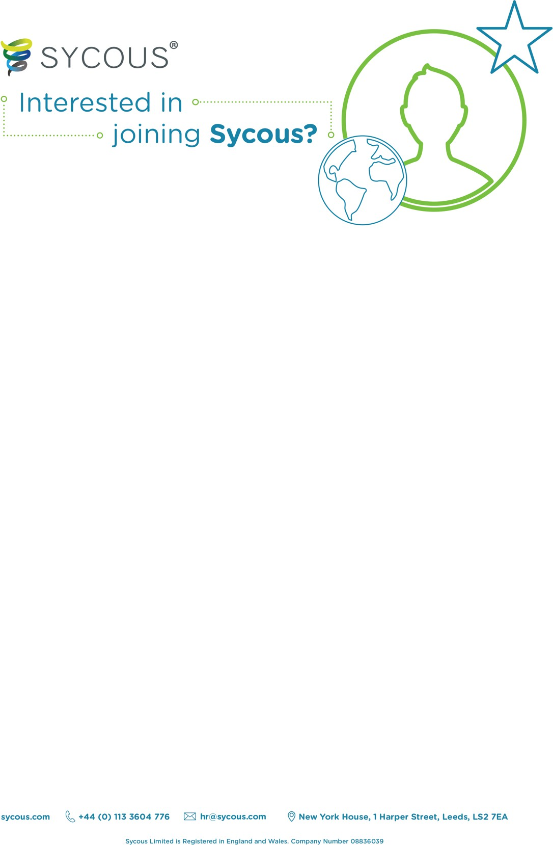

|  |  |  |  |
| --- | --- | --- | --- |
| Scheduling Coordinator | | | |
| Company | Sycous Limited | Team | Project Delivery Team |
| Date Posted | July 2025 | Mentor | Gina Carrington |
| Start Date | August 2025 | Role Type | Full Time/ Permanent |
| Role Overview | | | |
| Sycous provides innovative billing solutions for heat networks and district heating systems. On behalf of Heat Network Operators and other private utility network owners, we offer a market-leading engineering services solution.    The purpose of this role is to deliver excellent customer service and scheduling support to our internal and external customers.    We are looking for someone who is proactive and reliable, someone who is passionate about exceptional customer service and someone who can show a creative approach to solving problems. | | | |

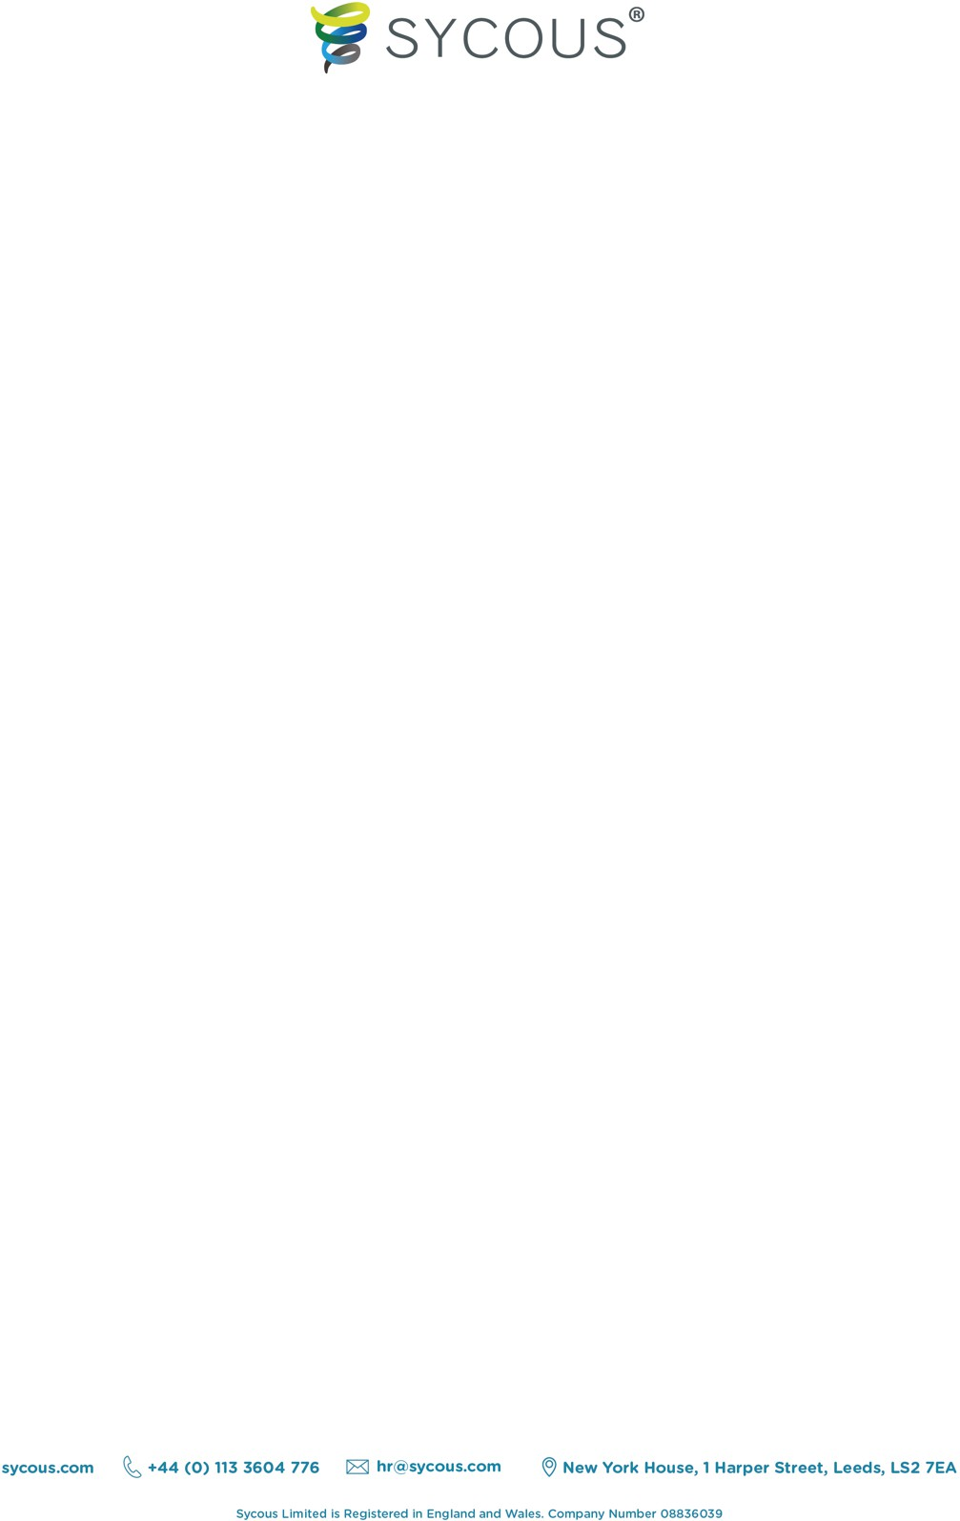

|  |
| --- |
| Key Responsibilities |
| Support our Sycous engineering and HIU Service customers by:     * + Scheduling all reactive, planned and project work accurately to appropriate resource, paying attention to location, expertise, and response targets.   + Utilisation of Big Change University to ensure knowledge of JobWatch is kept up to date.   + Ensure Stock is added to JobWatch.   + Ensure all engineer absences are logged on Jobwatch in a timely manner and all jobs for absentee engineer are re-scheduled. This includes contacting residents to re-arrange the appointment and informing clients where no contact has been established.   + Charge works via Unleashed or Job Watch   + Creating quotes for Maintain works via Job Watch and Unleashed.   + Handling of complaints from both residents and clients.   + Attend client meetings as and when required, taking appropriate notes and feeding back to relevant departments.   + Creation and collation of reports on an adhoc basis as and when required.   + Providing quality assurance on a daily basis regarding completed jobcards. Providing feedback to engineers, and Project and Delivery Lead where required and ensuring all Job Cards are issued out to relevant parties within 24 hours of completion.   + Ensuring wider support team are aware of existing processes, any process changes and any upcoming changes to processes or procedures.   + Ensuring that the engineer days are optimised to drive maximum productivity from the team.   + Reviewing information collated by engineers ensuring it is suitable and accurate.   + Monitoring engineer travel and activity and respond to issues as required.   + Escalating issues with specific jobs, clients, or engineers promptly.   + Liaising with customers to provide excellent support whilst making appointments and carrying out engineering work.   + Keeping our scheduling system up to date with accurate information. This includes:     - Address Details     - Engineer Skillsets     - Job results     - Job information     - Engineer holiday and sickness   + Keeping our Mabdeck system up to date with all metering information following a meter exchange/installation/configuration.   + Proactively providing first line support for SaaS and Customer Billing Services customers alike through all mediums of interaction including via phone, email, live chat and any other communication channels   Continuously improve and uphold our excellent level of customer service by:   * Work collaboratively and proactively with the Sycous team to ensure timely and accurate resolution of queries and to update on progress. * Adhering to internal SOPs, whilst providing suggestions for improvement where you find they are required. |



|  |
| --- |
| * Dealing with communications in a professional and prompt manner. * Reporting any training needs to your line manager. * When required aid Support Coordinators. This can include but is not limited to; telephone support, email support, online chat and adhoc administrative tasks. |
| Competencies |
| Required   * Excellent Customer Service * Attention to detail. * Excellent communication, both verbal & written. * Familiarity with data entry software * Ability to work well in a team. * Basic Mathematical skills * Customer Support * Task organisation * Task & time management * Computer literate including Microsoft Word and Excel * Resolution focused * Reliable * Problem-solving abilities     Desirable   * + Remote technical support   + Customer Support Experience   + Utilities Experience   + Zendesk Experience   + Previous experience in scheduling & management of diaries   + SaaS support experience   Working Hours: 8:00AM until 18:00PM. Shift patterns will be fixed on a 2-weekly basis.    Mon-Fri  08:00 – 18:00    Sat  08:00 – 16:00 |
| Future Progression |
| Future progression is available as the company grows or within other teams. We will frequently review your progress in your monthly 1-2-1s and 6-monthly performance reviews to identify what your ideal progression path is, and how we can help you to achieve it. |
| Renumeration |



|  |
| --- |
| Band: S1, Health Insurance, Pension Contribution, Health Cash Plan |
| Location |
| Reporting office: Leeds  Based: Leeds/Home. Travel may be required for training or other tasks in very limited circumstances with potential overnight stays. |
| About Sycous |
| We are experts in supporting energy network operators with open protocol metering hardware, software, and services.  We have industry leading knowledge and expertise in open protocol metering and data collection equipment, a skilled team of engineers for installation and maintenance, and an unrivalled customer service team for client and consumer support.  We are also the developers of the UK’s first cloud based, remote data collection administration software for use in the district heating and communal energy market.  We believe in a sustainable future with transparent and accessible data at the heart of it.  We champion both innovation and education, to help drive positive change in the world of metering and billing and help keep costs as low as possible for consumers.  Icon  Description automatically generated  [sycous.com](https://sycous.com/)  Logo  Description automatically generated Logo, company name  Description automatically generated  [mysycous.com](https://mysycous.com/) [sycous.com/solutions/mabdeck-software](http://www.sycous.com/solutions/mabdeck-software)    [sycous.com/orbit](http://www.sycous.com/orbit) [hiuservice.co.uk](http://www.hiuservice.co.uk/) |